User Guide for Roster system
Manage Section:

Employee Master Data
This menu link takes the user to employee information fetched from the TimeNex database. There are two types of employees data;
- Data directly entered into TimeNex
- Data fetched from SAP.
The user can perform following functions on this screen;
- Create a new employee
- Update an existing employee information (includes working position & working unit)
- Change status of non-SAP employee from active to inactive and vice versa

Shifts
Naufar defines and stores shift master data in the SAP. Timenex pulls the same master data into local database and then shift definitions including start time, end time etc. are provided in the Timenex database.
A user can perform following actions on this page;
- Create a new shift definition which includes providing time and resource management details. 

- Update an existing shift definition

The user double clicks (or can select the record and click edit icon in the action menu described above) of the record to be updated and it opens as shown below; 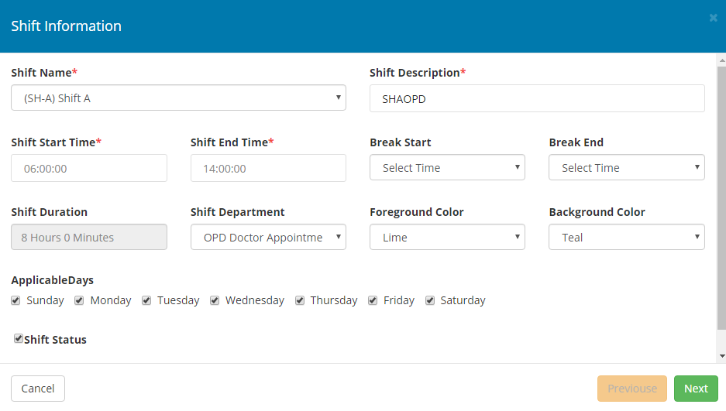
The user can make changes as per the requirements and presses next to confirm and save information.
- A shift, with respect to a department, can be activated or deactivated.
In the above screen, user can check the last checkbox to activate the shift. If the same checkbox is unchecked, the shift would be deactivated.

Tasks
User can follow this link to add desired tasks to be used in the roster view. This is just the master data creation and is linked with rosters definition and resource allocation.
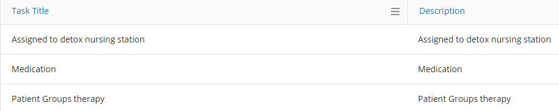
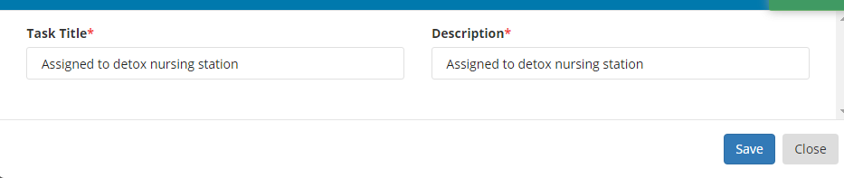Positions
The positions menu is very similar to tasks however this offers an additional features of status for the position which could be set to active and inactive. Following screens illustrate the process.
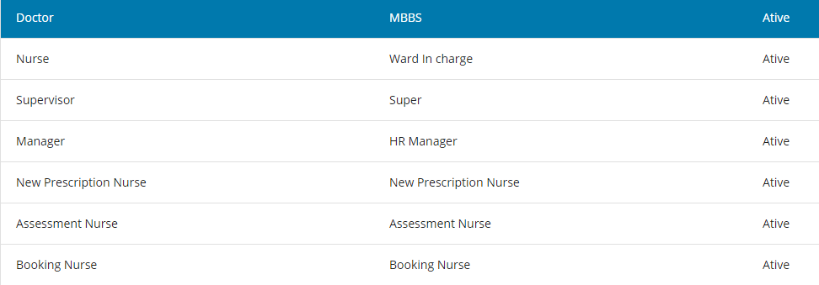
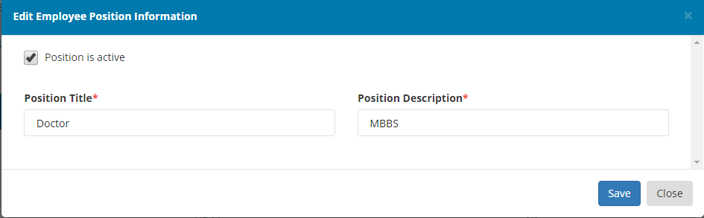

Skills
The Skill menu is very similar to positons however this offers an additional features of status for the active which could be set to active and inactive. Following screens illustrate the process.
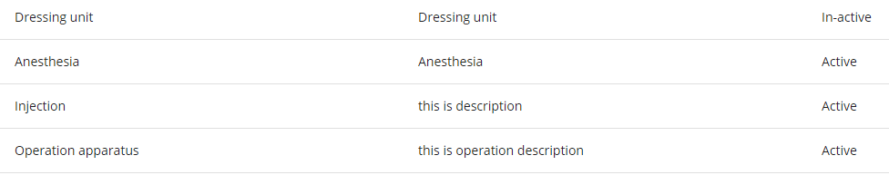
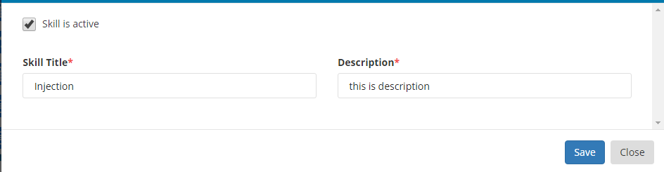

Units
The Unit menu is very similar to Skill however this offers an additional features of status for the active which could be set to active and inactive. Following screens illustrate the process.
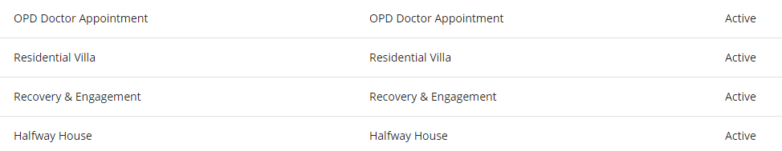

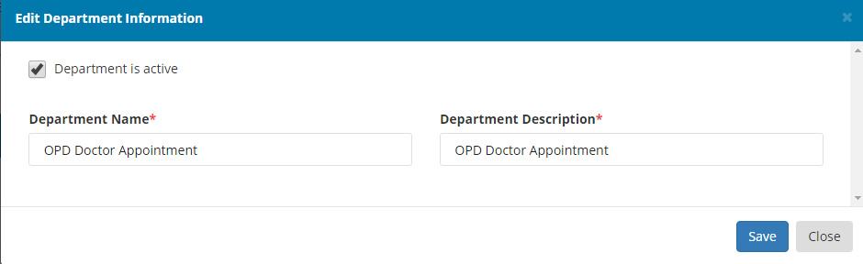

Transfer employee
This link enables the user to select an employee to move his/her to another department from their existing one. The process has two steps;
- Click on add button in the action menu
- Input the employee number and the data is fetched from database as you key-in the employee number.
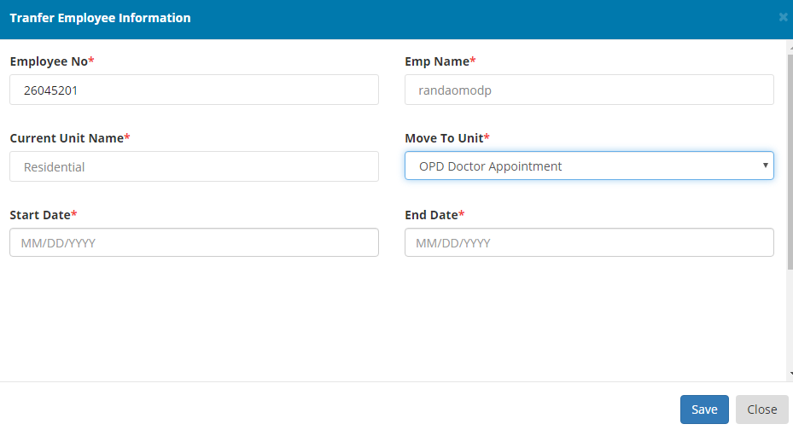
- The fetched information includes employee name and their current department.
- User can select new department under ‘Move To Unit’ label.
- User provides start and end date. End date is optional and is required when the employee is being transferred for a specific duration of time.
Above is the listing of all such actions performed on the transfer window. This listing is available to all departments
Schedule:

Create Roster
Step 1:
Click on the add icon as shown below

Step 2:
Provide necessary information to start roster definition;
- Select the unit for which you wish to create the roster
- Select the number of days for which you want the system to generate your initial roster. The available options are cycles for 28, 30 and 39 days respectively. It must be noted that these are specific durations for which the rosters are created and the system is thoroughly tested for the same.
- Start date marks the first day of the roster to be applicable
- End date is selected automatically and marks the end of first cycle of the roster.
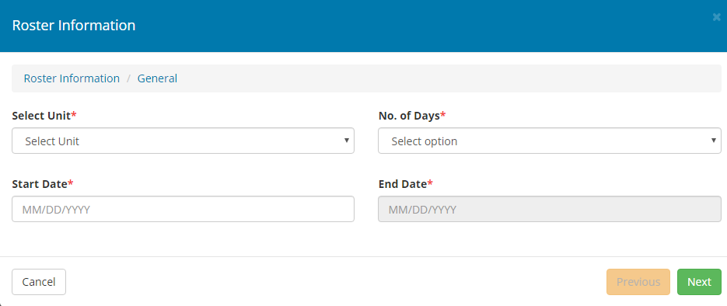
Step 3:
This step is about the selection of various shifts to be included in the planning for the roster. These shifts definitions are taken from the shift menu available under manage. If you don’t see any shifts, please go back to manage and complete the shift definition first.
User can select the required shifts, click next to move to step 4.
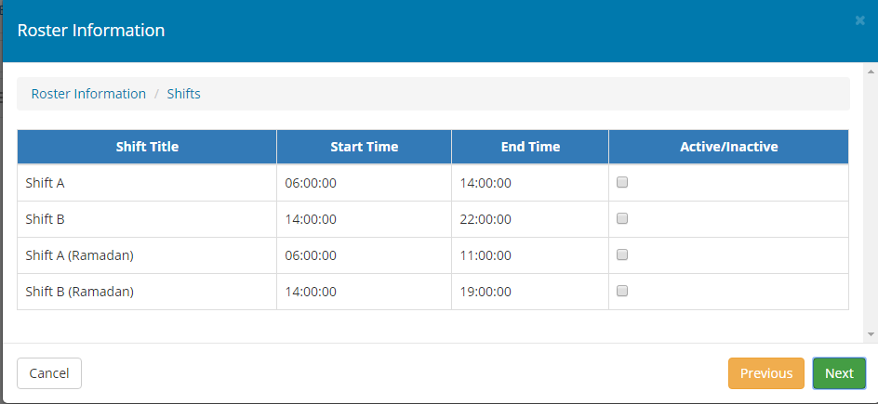
Step 4:
This is step is a simple preview of available/required resources based on the selected shifts for the unit under scheduling process. These resources are only the designations required by the shift definition and the actual resource planning takes place in the next step.
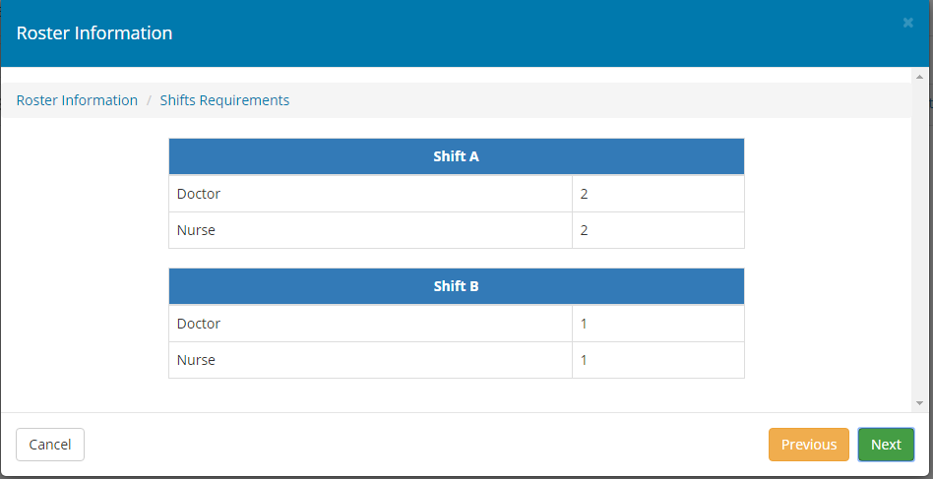
Step 5:
This step shows the availability of resources in the selected department and as per the required roles already shown in the previous preview. The user can deselect an already selected employee for the scheduling. This view is mainly for information purpose and user is not required to make any changes
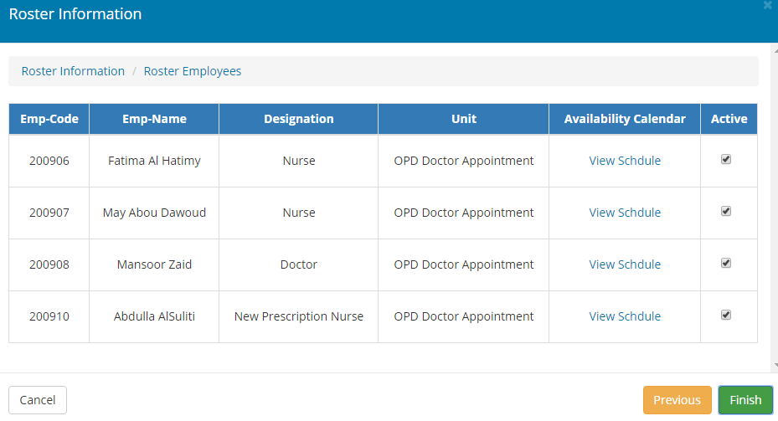

Roster View
Upon finishing the definition part, the user is automatically redirected to the roster view. The process might take a little while and the next screen shows the roster view. Now, based on the information selected and shown in previous steps, user has everything ready for drag and drop planning of their roster. The user will have the liberty to use various combinations for the staff, based on their skill set and other important requirements;
Step 1:
This screen shows the blank screen, with all available resources, selected time duration and shifts.
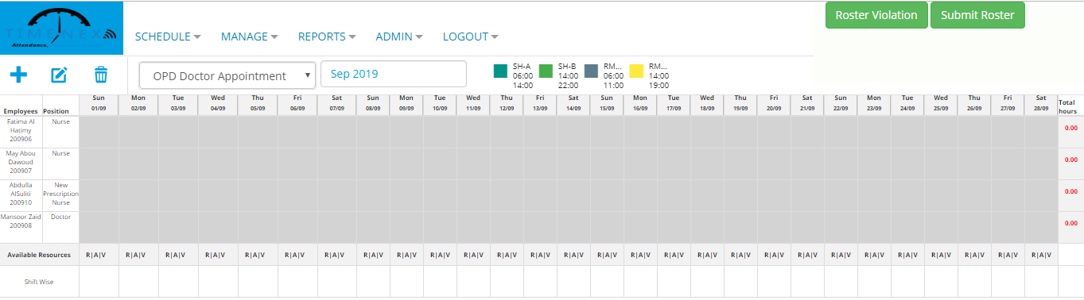
Step 2
User starts scheduling at this step. Click on any slot as shown in the picture below and select Bulk Assignment option to start scheduling.
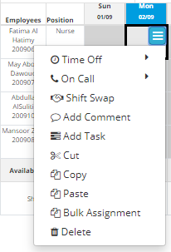
Step 2:
Clicking Bulk Assignment opens the screen below. User can select the desired shift for that resource and plan his schedule for the desired number of days. This enables the user to either keep an employee in the same shift for whole duration of roster or provide a different weekly schedule or whichever way they wish to execute. Saving this information would generate the schedule for selected employee, with in the selected shift for the provided date span.
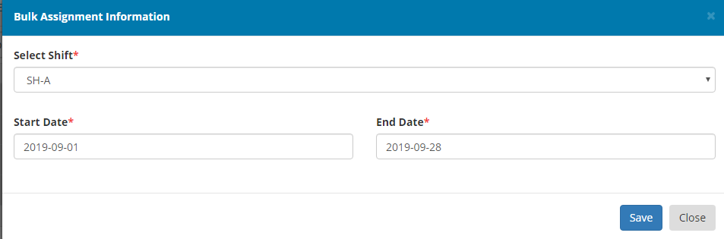
Step 3:
When redirected back to main roster view, the schedule for selected employee is created and is visible along with the total working hours for the duration of the roster or the selected duration whichever the case may be.
User will have the liberty to edit this information any number of time before they are satisfied with the schedule and can post it for further approval process.

Example: The picture below shows the exactly same schedule created in previous step but the resource deployment is changed to another shift for the second week.

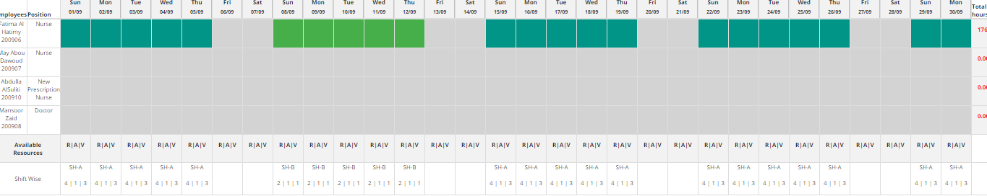

Generate for Year
Step1:
Click on the “Generate for year” button in Action column as shown below :
Step2:
Then Press the button and It will generate the Roster for whole year.
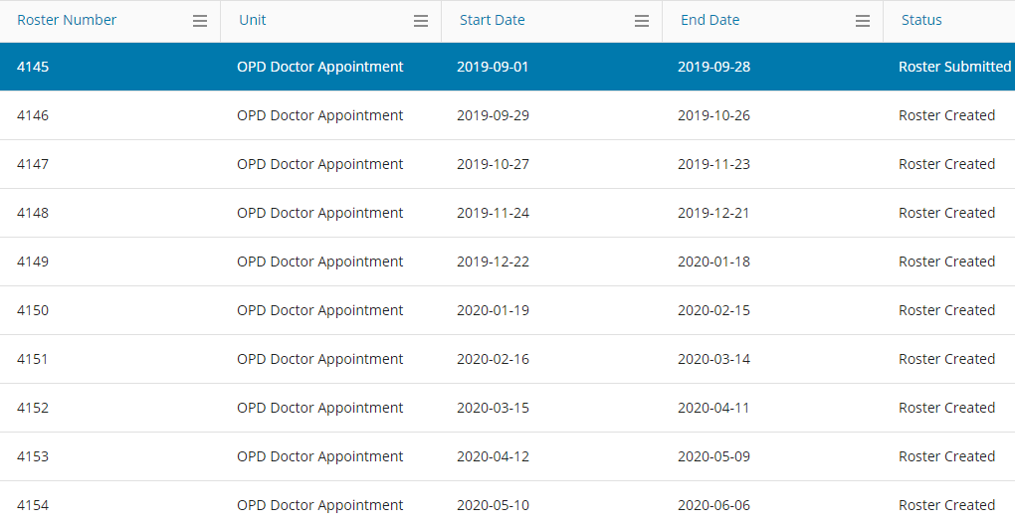

Ramadan Roster:
Step 1:
Click on the add icon as shown below

Step2:
Provide necessary information to start Ramadan Roster definition.
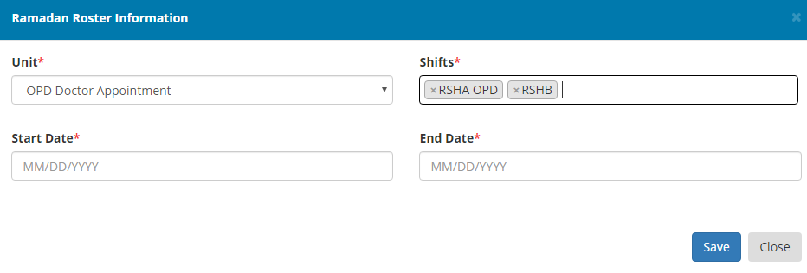

Transfer Roster

Step1:
Click on the add icon as shown below


Step2:
Provide necessary information to about Effective date of employee for Transfer Roster definition.

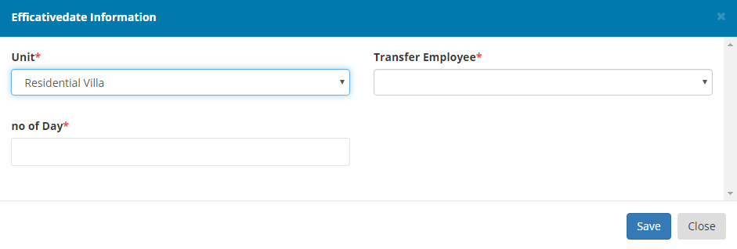
Step3:
Roster view will open only for that employee and assign shift to it and then press Submit it will generate the roster for selected effective date.

Rollover
Step 1:

Step 2:
Provide the necessary information and click save to Rollover.
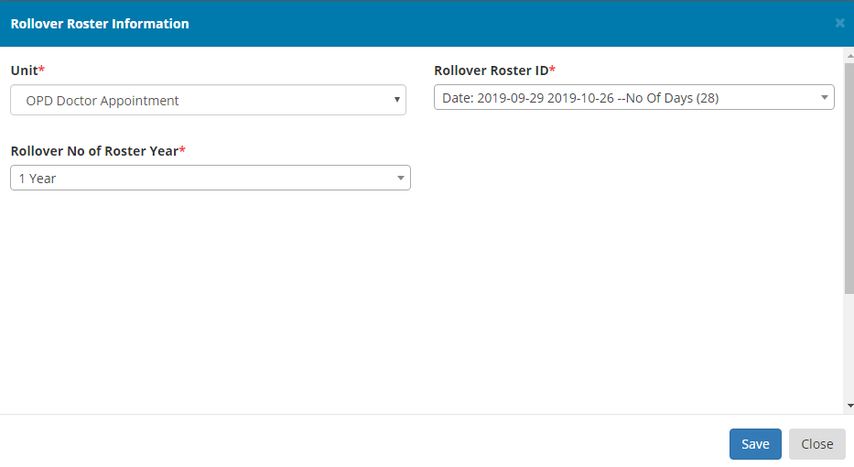

Add Task Feature on Roster View:
Step1:
Click Add Task

Step2:
Select the listed task and click Save
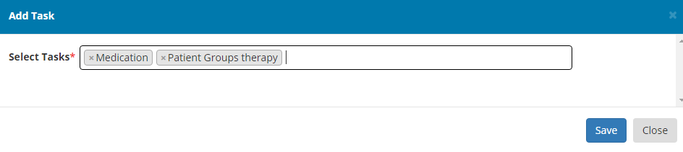

Add Comment Feature:
Step1:
Click Add Comment

Step2:
Write the comment and click Save
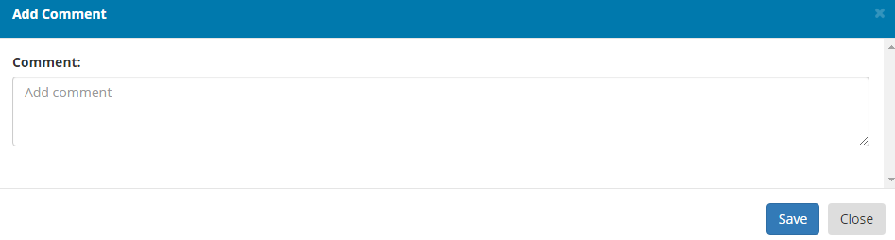Add Non SAP Leave:
Step1:
Click Time OFF and click the desired leave. 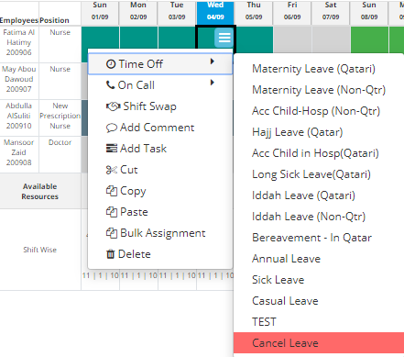

Add On Calls Assignments:
Step1:
Click On call and then click on any on call assignment
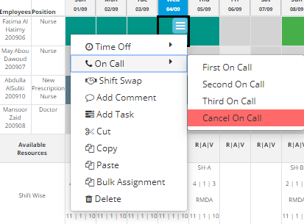

Employee Shift Swapping Between & Individual Employee:
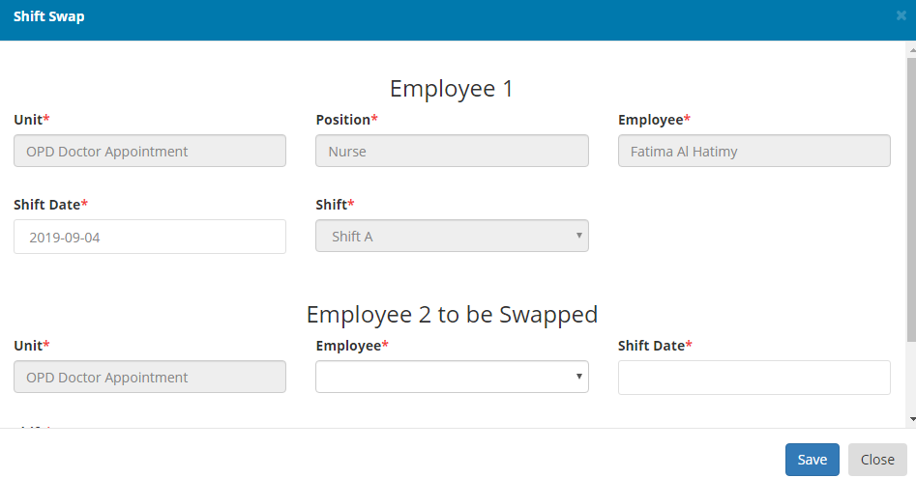
Reports:
Unit wise report
Employee wise report
Admin:

Roles creation
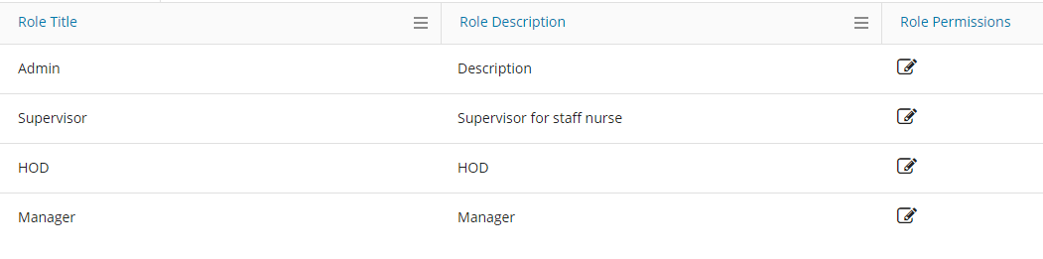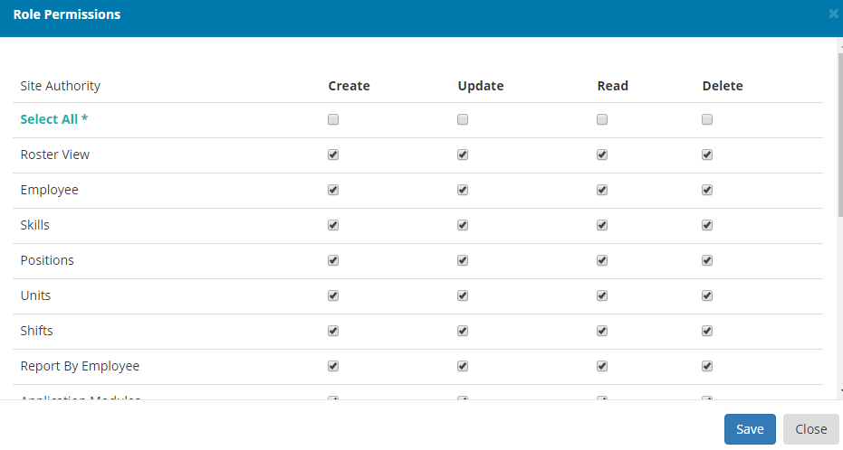

User Creation
Step1:

Step2:
